Bug title: Label "Benefit cost" is confusing does not specify if it costs to employee or employer
Tester’s Name & ID: Antonio Acosta Flores (antonio.acostafl@gmail.com)
Test Environment: https://wmxrwq14uc.execute-api.us-east-1.amazonaws.com
Priority: 5
Severity: 5

Steps to reproduce the bug:

No. Step | Step Description | Expected Result
1 | Log in into Benefits Dashboard application | User is able to log into the Benefits Dashboard
2 | Check the “Benefits Cost” field. | The field should be clear about who needs to cover the cost.

Steps with evidence:

No. Step | Step Description | Expected Result
1 | Log in into Benefits Dashboard application | User is able to log into the Benefits Dashboard

Result:
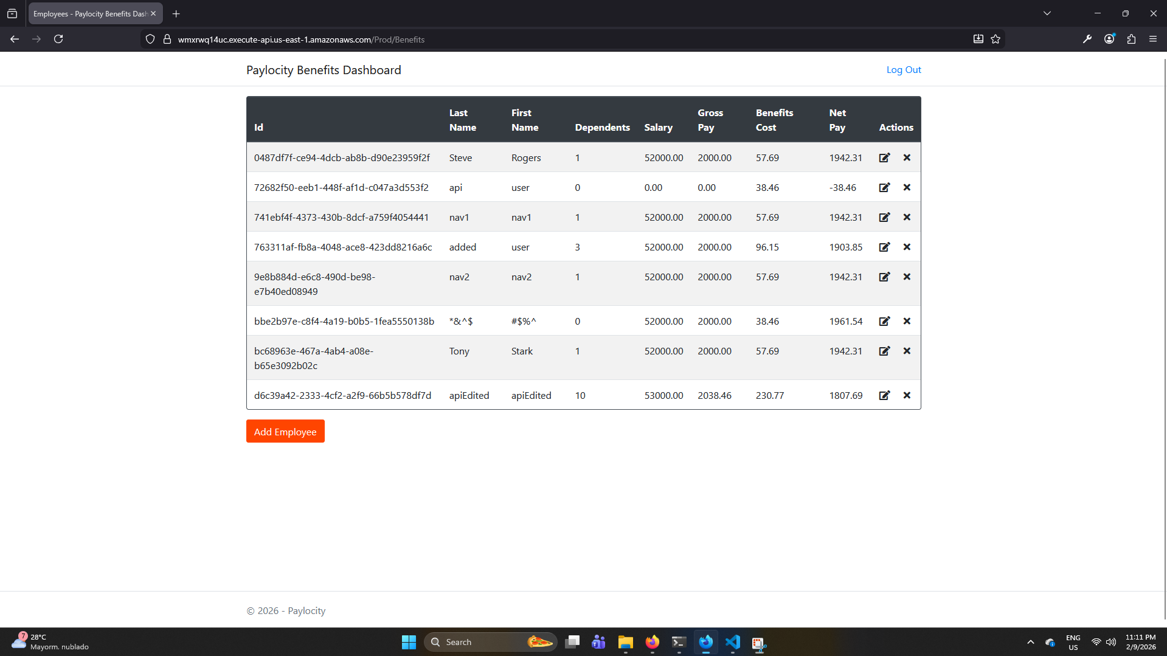

Actual Result: Field “Benefits Cost” is confusing and is not clear about who needs to cover the displayed amount.

Bug title: No unit of measure for benefits either per paycheck or year is shown in the dashboards resulting in confusion to understand the Employee Benefits and payment.
Tester’s Name & ID: Antonio Acosta Flores (antonio.acostafl@gmail.com)
Test Environment: https://wmxrwq14uc.execute-api.us-east-1.amazonaws.com
Priority: 5
Severity: 5

Steps to reproduce the bug:

No. Step | Step Description | Expected Result
1 | Log in into Benefits Dashboard application | User is able to log into the Benefits Dashboard
2 | Check the Benefits amounts | The benefits amounts are clear about how often are paid and payment frequency is not mixed among the fields.

Steps with evidence:

No. Step | Step Description | Expected Result
1 | Log in into Benefits Dashboard application | User is able to log into the Benefits Dashboard

Result:

Actual Result: Benefits amounts are confusing since it shows salary which is annual, all other amounts are per paycheck.

Bug title: Salary label do not make sense since Gross salary is deducted
Tester’s Name & ID: Antonio Acosta Flores (antonio.acostafl@gmail.com)
Test Environment: https://wmxrwq14uc.execute-api.us-east-1.amazonaws.com
Priority: 5
Severity: 5

Steps to reproduce the bug:

No. Step | Step Description | Expected Result
1 | Log in into Benefits Dashboard application | User is able to log into the Benefits Dashboard
2 | Check the “Salary” field compared with the “Net Pay” and the total Benefit cost calculated | Salary field should be clear about how much the employee is being paid along with the benefit costs by their benefit package.

Steps with evidence:

No. Step | Step Description | Expected Result
1 | Log in into Benefits Dashboard application | User is able to log into the Benefits Dashboard

Result:

Actual Result: Salary field is not accurate since real Salary cost for the employer is the gross salary minus the benefit cost deducted from the paycheck of the employee.

Bug title: Table Labels of First and Last names are no placed correctly
Tester’s Name & ID: Antonio Acosta Flores (antonio.acostafl@gmail.com)
Test Environment: https://wmxrwq14uc.execute-api.us-east-1.amazonaws.com
Priority: 1
Severity: 5

Steps to reproduce the bug:

No. Step | Step Description | Expected Result
1 | Log in into Benefits Dashboard application | User is able to log into the Benefits Dashboard
2 | Check the Second and Third columns. | Second and Third columns should match with the firstnames and lastnames of the employees.

Steps with evidence:

No. Step | Step Description | Expected Result
1 | Log in into Benefits Dashboard application | User is able to log into the Benefits Dashboard

Result:

Actual Result: The text in the labels of the second and third columns are in wrong places.

Bug title: When minimizing the windows less than 1200 px large the table displays a division in the middle of the table
Tester’s Name & ID: Antonio Acosta Flores (antonio.acostafl@gmail.com)
Test Environment: https://wmxrwq14uc.execute-api.us-east-1.amazonaws.com
Priority: 5
Severity: 5

Steps to reproduce the bug:

No. Step | Step Description | Expected Result
1 | Log in into Benefits Dashboard application | User is able to log into the Benefits Dashboard
2 | Maximize the window more than the range of 992 / 1200 px width | Table of the Dashboard should look clean
3 | Minimize the window below the range 992 / 1200 px width

Steps with evidence:

No. Step | Step Description | Expected Result
1 | Log in into Benefits Dashboard application | User is able to log into the Benefits Dashboard

Result:

2 | Maximize the window more than the range of 992 / 1200 px width | Table of the Dashboard should look clean

Result:
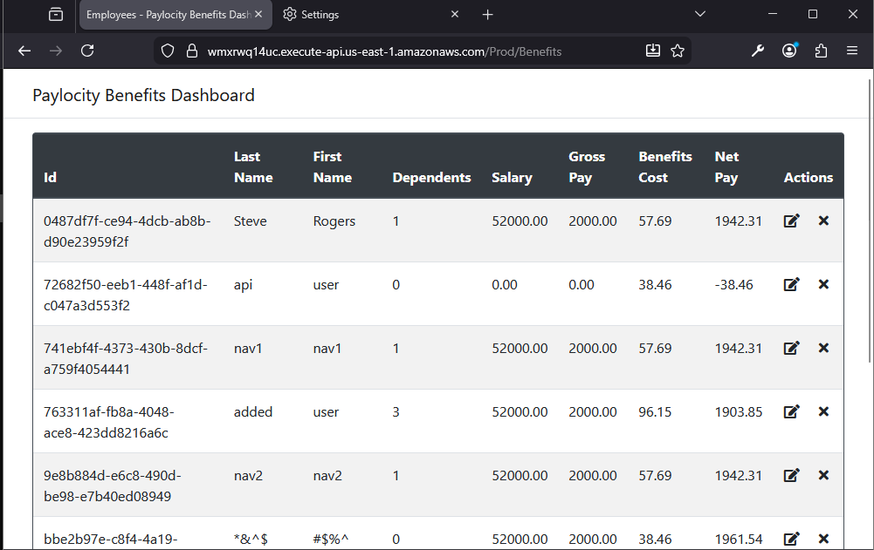

3 | Minimize the window below the range 992 / 1200 px width | A division is displayed in the middle of the table  Actual Result: A division is displayed in the middle of the table

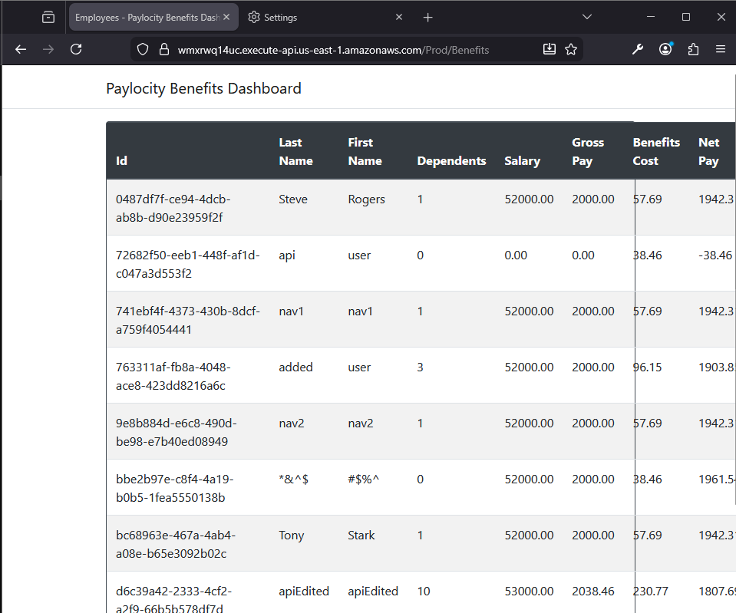
Bug title: Non alphabetic characters are allowed in the First and Last name fields
Tester’s Name & ID: Antonio Acosta Flores (antonio.acostafl@gmail.com)
Test Environment: https://wmxrwq14uc.execute-api.us-east-1.amazonaws.com
Priority: 5
Severity: 5

Steps to reproduce the bug:

No. Step | Step Description | Expected Result
1 | Log in into Benefits Dashboard application | User is able to log into the Benefits Dashboard
2 | Click on “Add Employee” button | An “Add Employee” window is displayed.
3 | Enter non-alphabetic characters in the Firstname and Lastname fields and a valid digit from the range of 0 to 32 into the Dependents field. | Characters are placed within the field.
4 | Click on Add Button | Only alphanumeric characters should be accepted by the Firstname and Lastname fields.

Steps with evidence:

No. Step | Step Description | Expected Result
1 | Log in into Benefits Dashboard application | User is able to log into the Benefits Dashboard

Result:

2 | Click on “Add Employee” button | An “Add Employee” window is displayed.

Result:
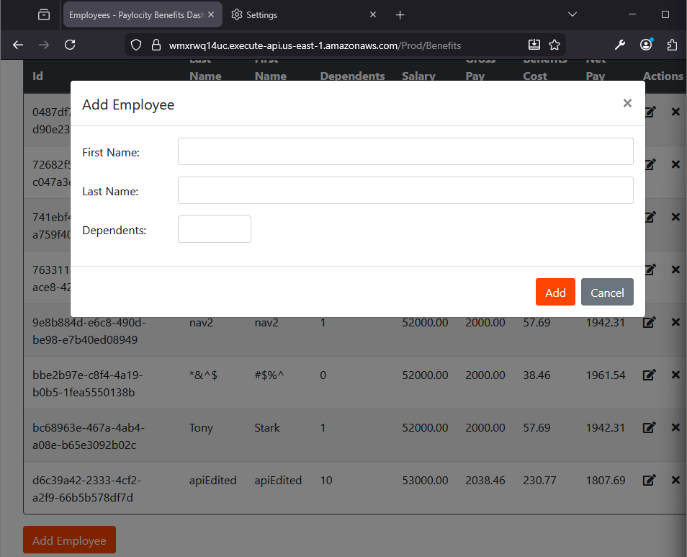

3 | Enter non-alphabetic characters in the Firstname and Lastname fields and a valid digit from the range of 0 to 32 into the Dependents field. | Characters are placed within the field.

Result:
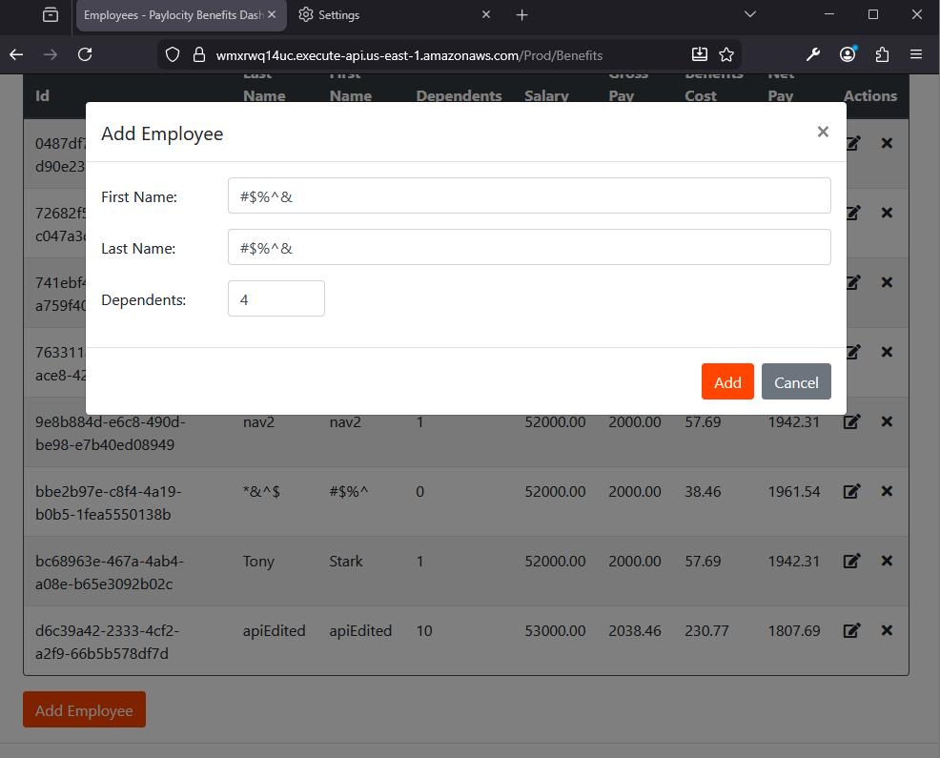

4 | Click on Add Button | Only alphanumeric characters should be accepted by the Firstname and Lastname fields.  Actual Result:.Firstname and Lastname are not validated to only include alphanumeric characters.

Result:
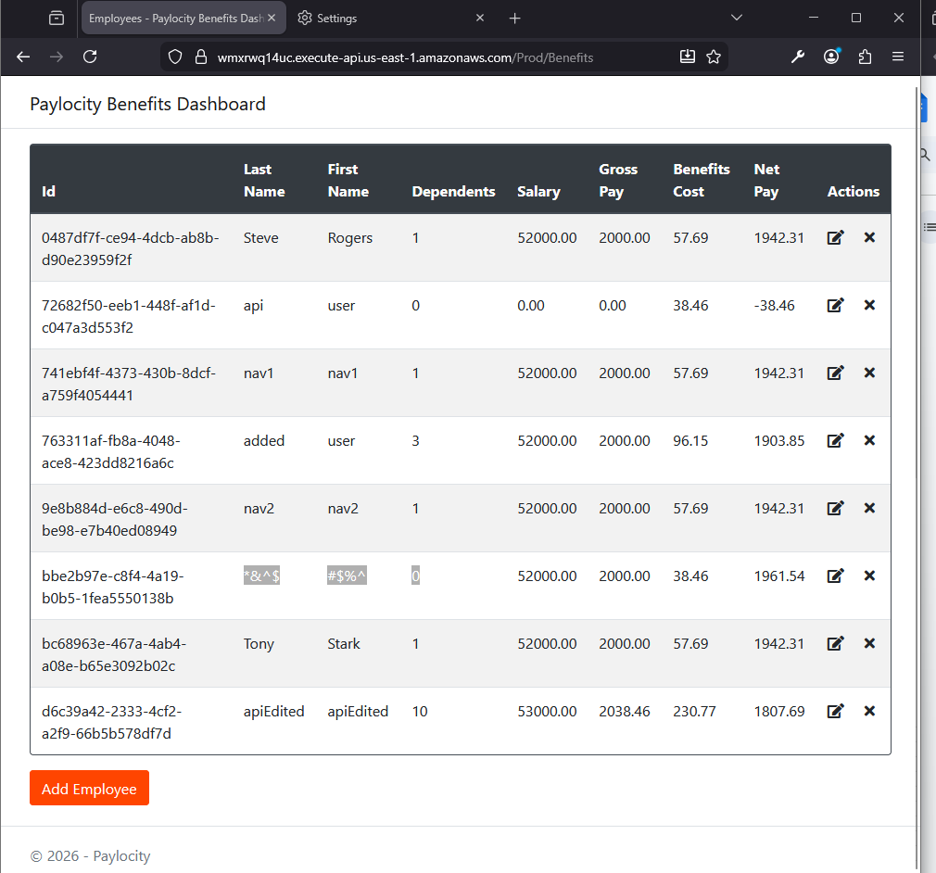

Bug title: No error alert of wrong input is displayed when submitting non-digits chars in the Dependent field.
Tester’s Name & ID: Antonio Acosta Flores (antonio.acostafl@gmail.com)
Test Environment: https://wmxrwq14uc.execute-api.us-east-1.amazonaws.com
Priority: 4
Severity: 4

Steps to reproduce the bug:

No. Step | Step Description | Expected Result
1 | Log in into Benefits Dashboard application | User is able to log into the Benefits Dashboard
2 | Click on “Add Employee” button | An “Add Employee” window is displayed.
3 | Enter alphabetic characters in the Firstname and Lastname fields and an alphabetic character into the Dependents field. | Characters are placed within the field.
4 | Click on Add Button | An error alert should be displayed in the UI when submitting an alphabetic character in the Dependents field.

Steps with evidence:

No. Step | Step Description | Expected Result
1 | Log in into Benefits Dashboard application | User is able to log into the Benefits Dashboard

Result:

2 | Click on “Add Employee” button | An “Add Employee” window is displayed.

Result:

3 | Enter alphabetic characters in the Firstname and Lastname fields and an alphabetic character into the Dependents field. | Characters are placed within the field.

Result:
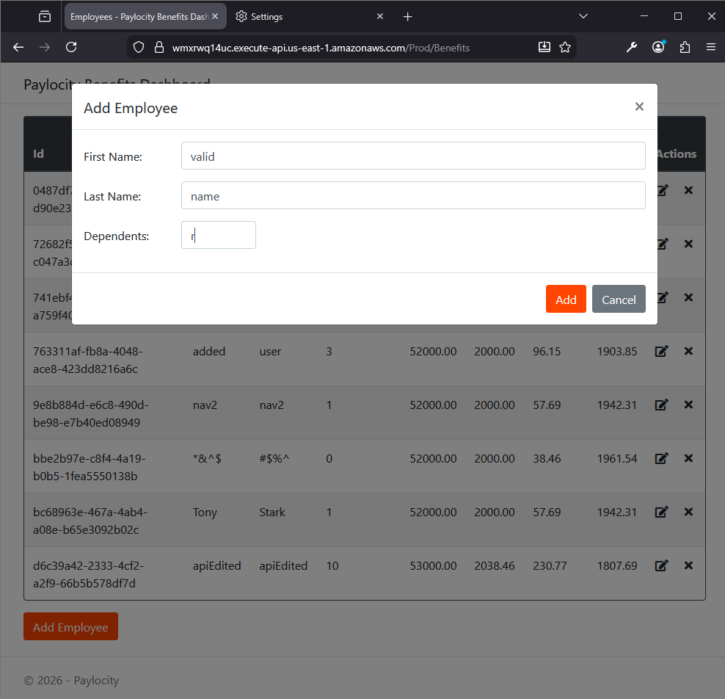

4 | Click on Add Button | An error alert should be displayed in the UI when submitting an alphabetic character in the Dependents field.  Actual Result: 405 error code is displayed when submitting the employee data but no error or any alert is displayed in the UI side.

Result:
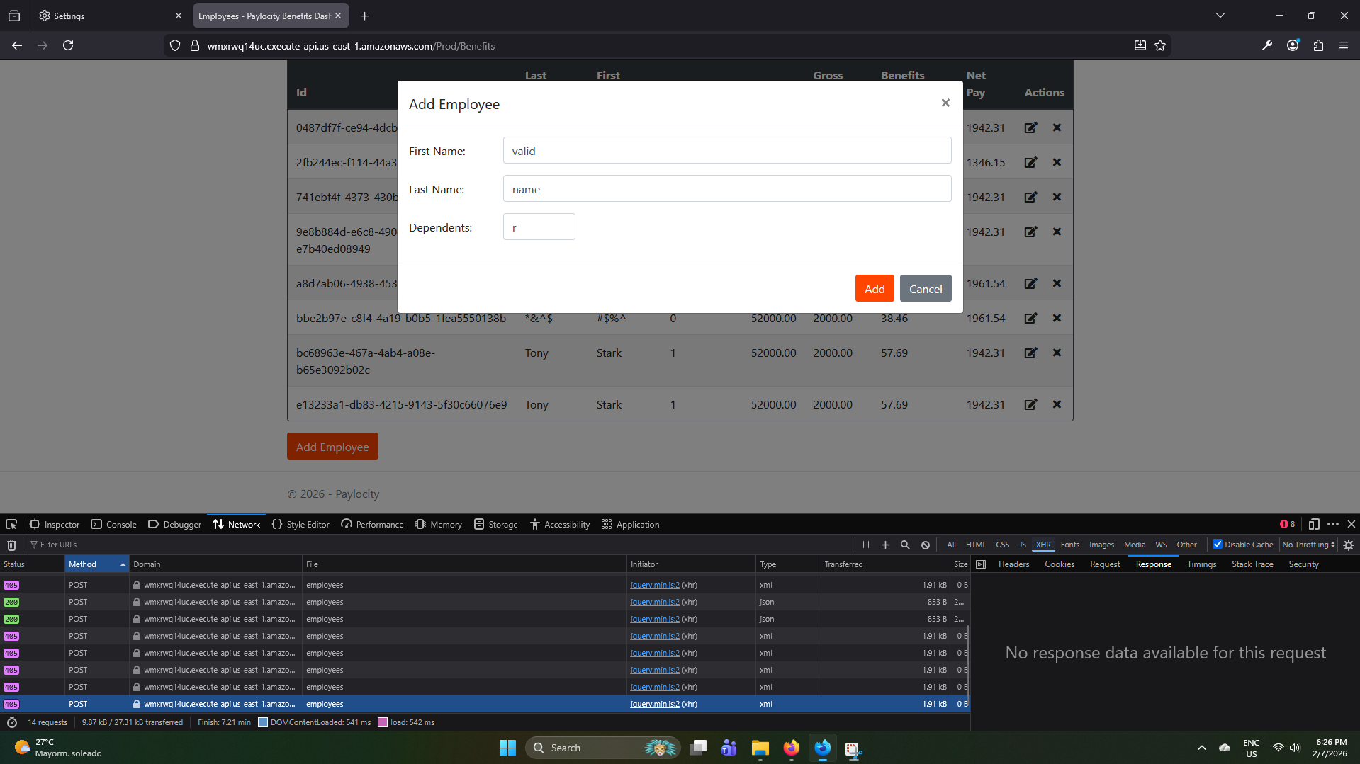

Bug title: After a while the application session ends and does not redirect to the login page and cause a failed user attempt to add an employee.
Tester’s Name & ID: Antonio Acosta Flores (antonio.acostafl@gmail.com)
Test Environment: https://wmxrwq14uc.execute-api.us-east-1.amazonaws.com
Priority: 4
Severity: 4

Steps to reproduce the bug:

No. Step | Step Description | Expected Result
1 | Log in into Benefits Dashboard application | User is able to log into the Benefits Dashboard
2 | Click on “Add Employee” button | An “Add Employee” window is displayed.
3 | After passing a while (5 min aprox) fill the Firstname and Lastname with alphabetic characters and Dependents field with digit from 0 to 32 | Characters are placed within the field.
4 | Click on the Add button. | Since the application is no longer active, application should send an alert of inactivity

Steps with evidence:

No. Step | Step Description | Expected Result
1 | Log in into Benefits Dashboard application | User is able to log into the Benefits Dashboard

Result:

2 | Click on “Add Employee” button | An “Add Employee” window is displayed.

Result:

3 | After passing a while (5 min aprox) fill the Firstname and Lastname with alphabetic characters and Dependents field with digit from 0 to 32 | Characters are placed within the field.

Result:

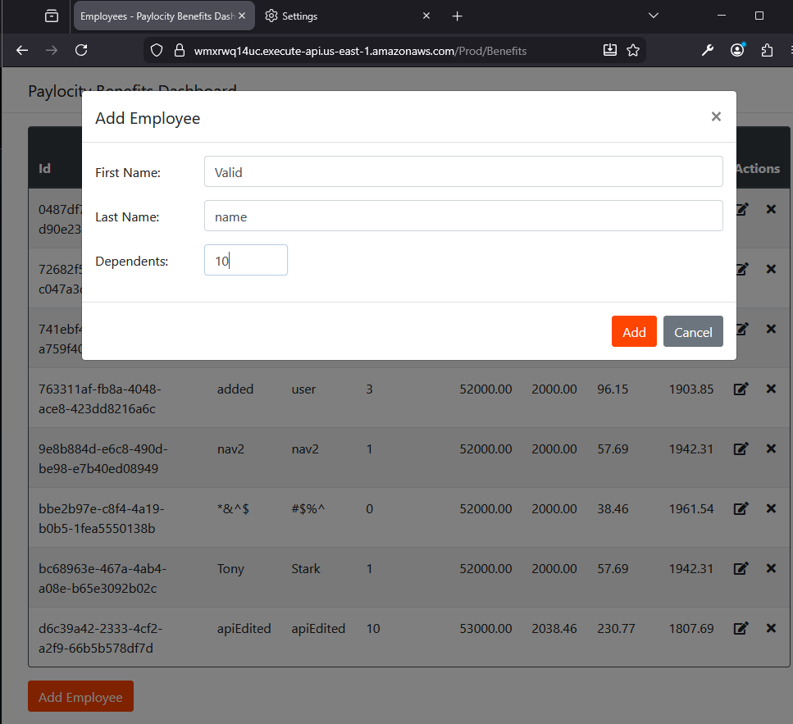

4 | Click on the Add button. | Since the application is no longer active, application should send an alert of inactivity  Actual Result: Error 401 code are displayed after trying adding the record and no alert of inactivity or error is shown in the UI side.

Result
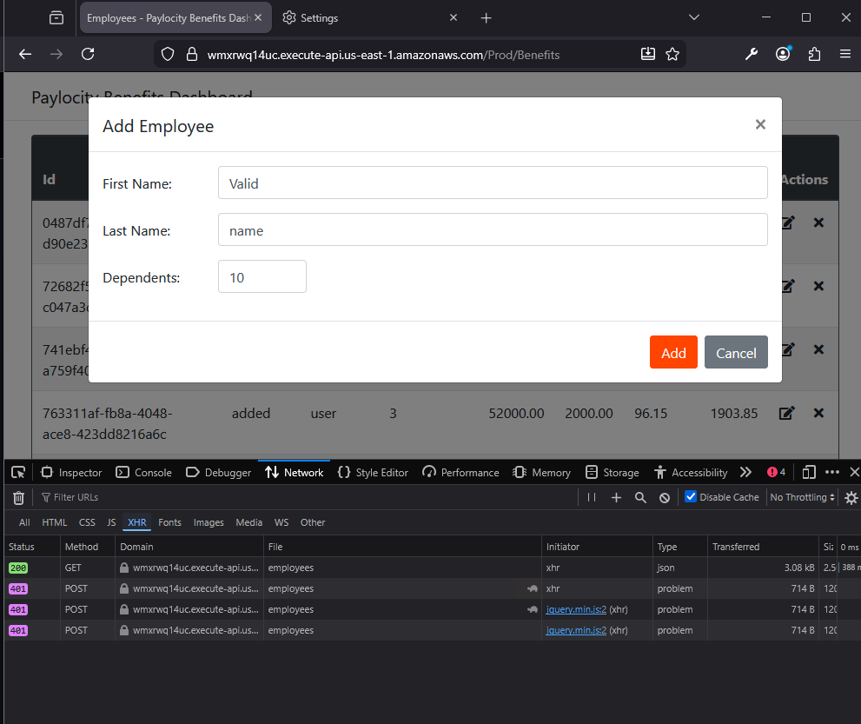

Bug title: User is not redirected to login page when going directly to /Prod/Benefits without previously logging in.
Tester’s Name & ID: Antonio Acosta Flores (antonio.acostafl@gmail.com)
Test Environment: https://wmxrwq14uc.execute-api.us-east-1.amazonaws.com
Priority: 3
Severity: 3

Steps to reproduce the bug:

No. Step | Step Description | Expected Result
1 | Go to the Login page of Benefits Dashboard | User should see the fields to enter the credentials.
2 | Go directly to the Benefits Dashboard url direction | User should be immediately redirected to Login Page.

Steps with evidence:

No. Step | Step Description | Expected Result
1 | Go to the Login page of Benefits Dashboard | User should see the fields to enter the credentials.

Result:
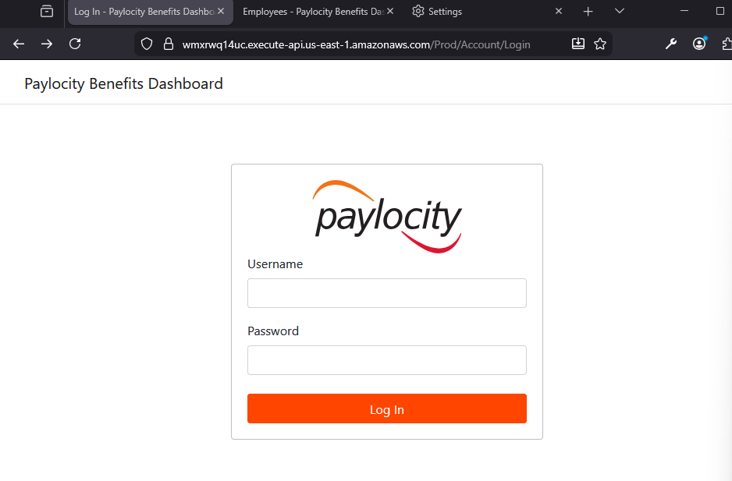

2 | Go directly to the Benefits Dashboard url direction | User should be immediately redirected to Login Page.  Actual Result: User can go to the Benefits Dashboard page.

Result:
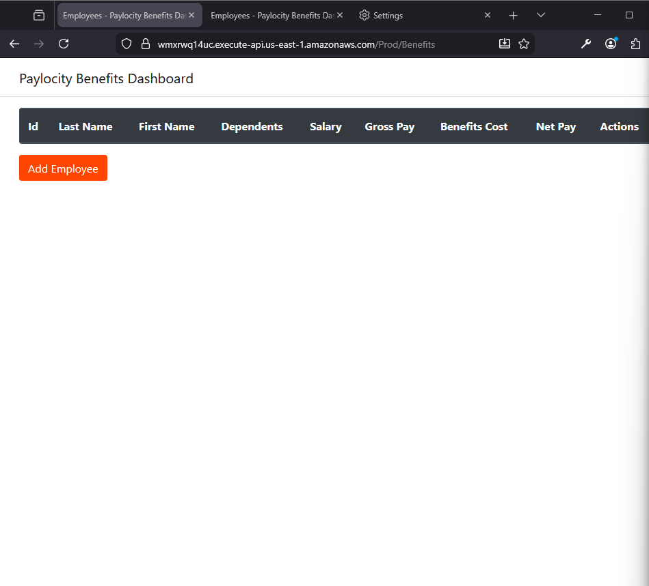

Bug title: User is not redirected to login page when going directly to /Prod/Benefits without previously logging in.
Tester’s Name & ID: Antonio Acosta Flores (antonio.acostafl@gmail.com)
Test Environment: https://wmxrwq14uc.execute-api.us-east-1.amazonaws.com
Priority: 3
Severity: 3

Steps to reproduce the bug:

No. Step | Step Description | Expected Result
1 | Log in into Benefits Dashboard application | User is able to log into the Benefits Dashboard
2 | Refresh the page | The page should be refreshed and the user can see the records within the table.

Steps with evidence:

No. Step | Step Description | Expected Result
1 | Log in into Benefits Dashboard application | User is able to log into the Benefits Dashboard

Result:

2 | Refresh the page | The page should be refreshed and the user can see the records within the table.  Actual Result: 401 error code is shown, correct refresh happened after several times.

Result:

Bug title: Log out link not shown after successful reloading page after several tries
Tester’s Name & ID: Antonio Acosta Flores (antonio.acostafl@gmail.com)
Test Environment: https://wmxrwq14uc.execute-api.us-east-1.amazonaws.com
Priority: 3
Severity: 3

Steps to reproduce the bug:

No. Step | Step Description | Expected Result
1 | Log in into Benefits Dashboard application | User is able to log into the Benefits Dashboard
2 | Refresh the page to see the behavior reported in the previous bug. | The page should not load the table after refreshing.
3 | Refresh the page again until the successful page load. | All elements of the page should load successfully.

Steps with evidence:

No. Step | Step Description | Expected Result
1 | Log in into Benefits Dashboard application | User is able to log into the Benefits Dashboard

Result:

2 | Refresh the page to see the behavior reported in the previous bug. | The page should not load the table after refreshing.

Result: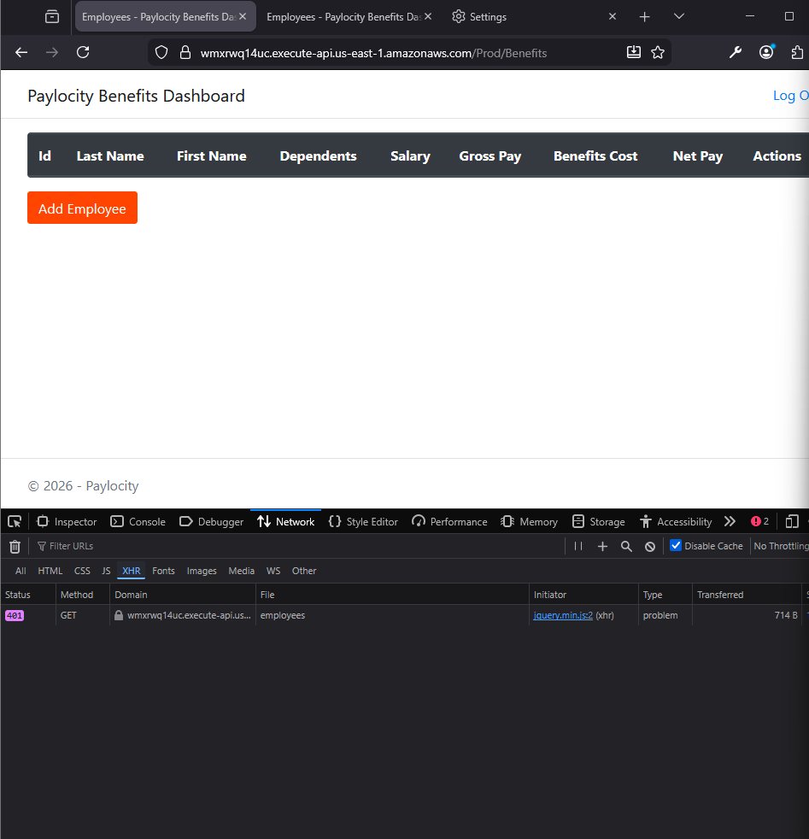

3 | Refresh the page to see the behavior reported in the previous bug. | The page should not load the table after refreshing.  Actual Result: The Log out link does not load after the table and records reloads successfully.

Result:
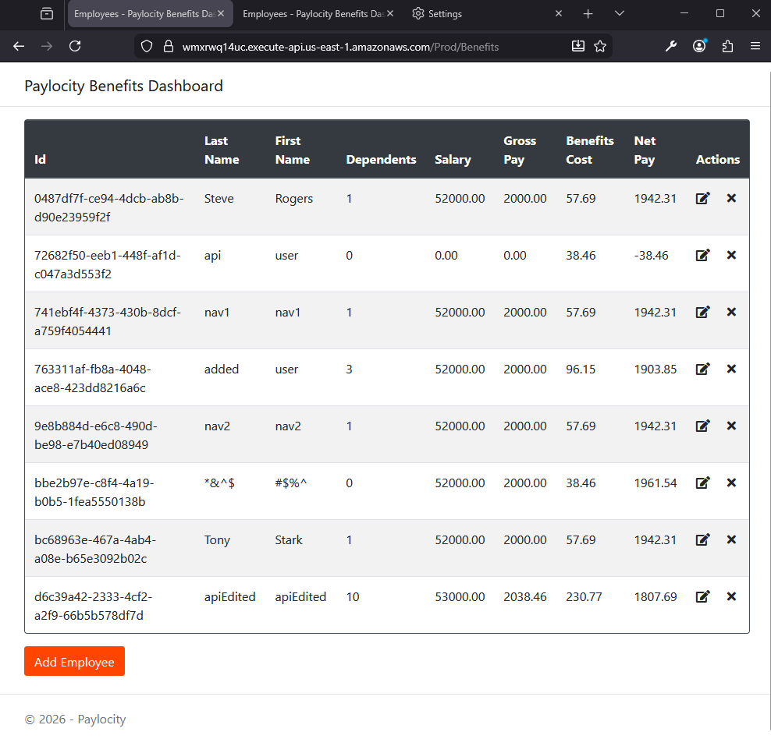

Bug title: App allows same user logging in two different browsers.
Tester’s Name & ID: Antonio Acosta Flores (antonio.acostafl@gmail.com)
Test Environment: https://wmxrwq14uc.execute-api.us-east-1.amazonaws.com
Priority: 3
Severity: 3

Steps to reproduce the bug:

No. Step | Step Description | Expected Result
1 | Log in into Benefits Dashboard application in one browser instance | User is able to log into the Benefits Dashboard
2 | Log in into Benefits Dashboard application in another browser | User is able to log into the Benefits Dashboard
3 | Add a new Employee from the last logged in browser | Employee should be added successfully
4 | Add other Employee from the other browser | Employee should not be added

Steps with evidence:

No. Step | Step Description | Expected Result
1 | Log in into Benefits Dashboard application in one browser instance | User is able to log into the Benefits Dashboard

Result:
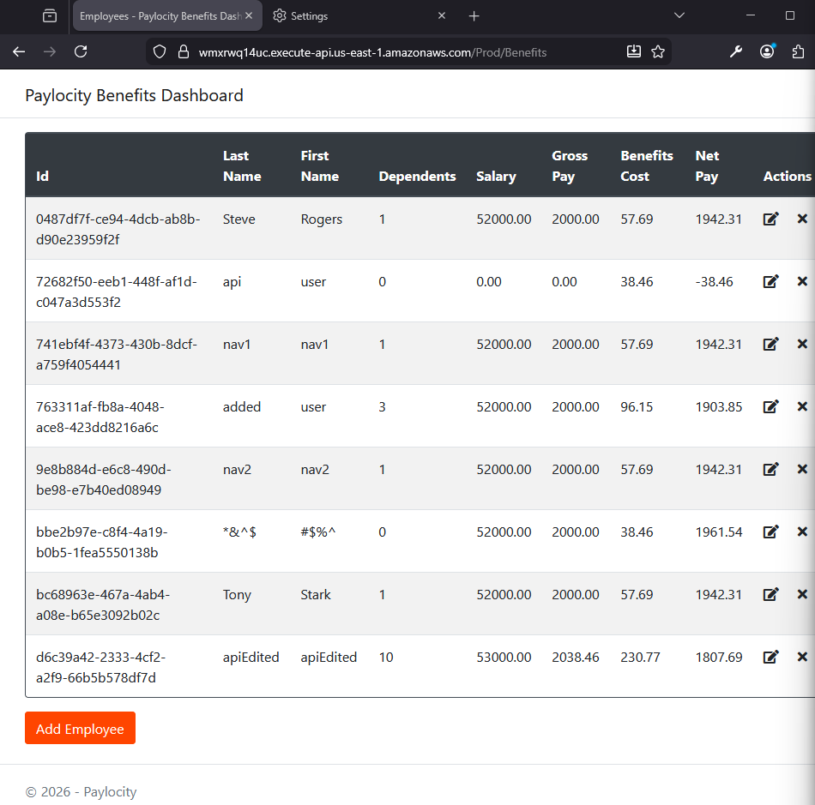

2 | Log in into Benefits Dashboard application in another browser | User is able to log into the Benefits Dashboard

Result:

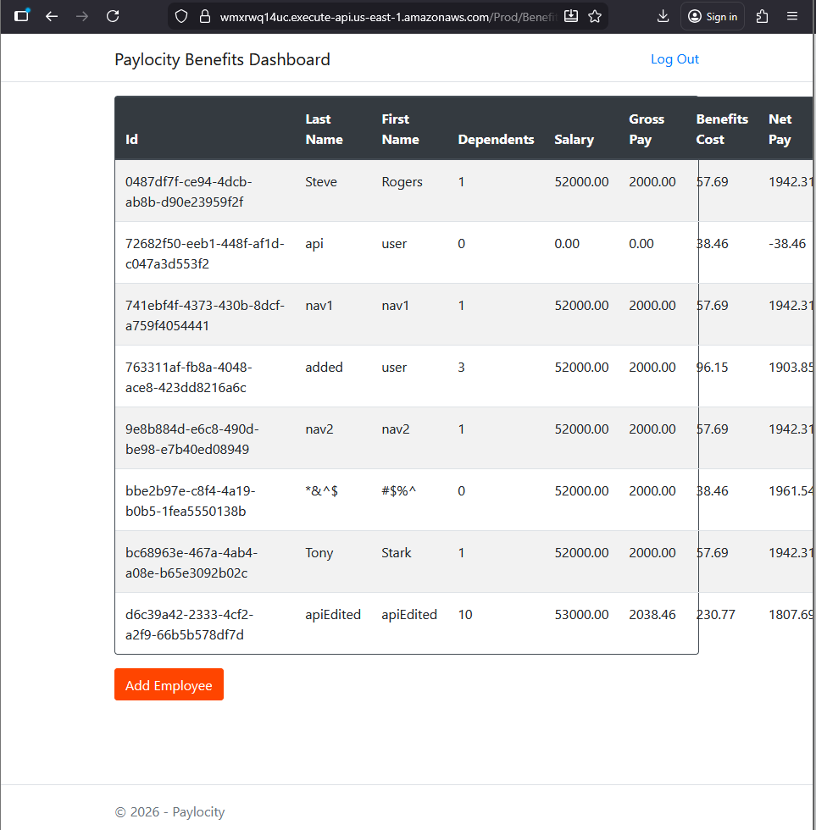

3 | Add a new Employee from the last logged in browser | Employee should be added successfully

Result:
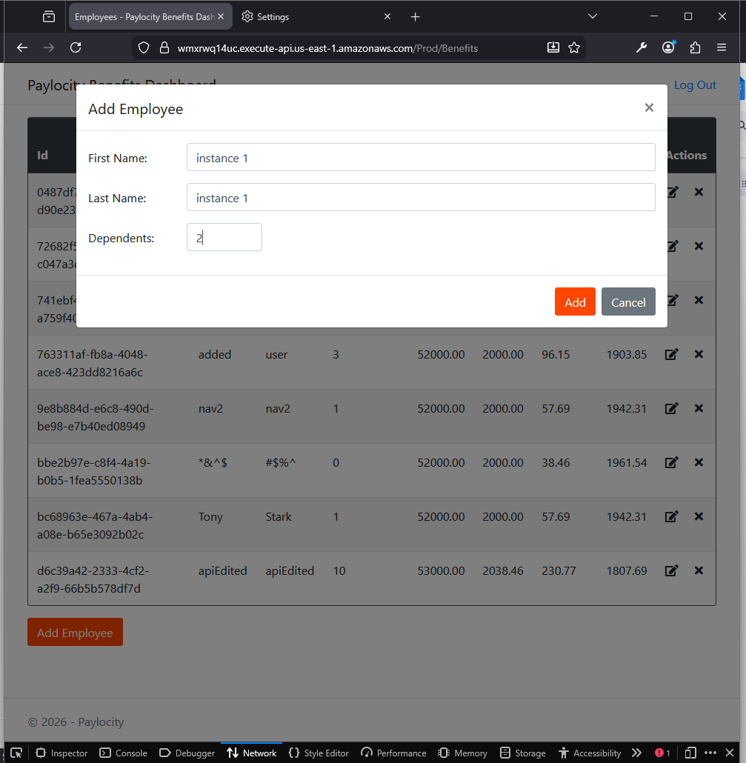

4 | Add other Employee from the other browser | Employee should not be added  Actual Result:  Same user can perform operations in the application from 2 different browser at the same time.

Result:

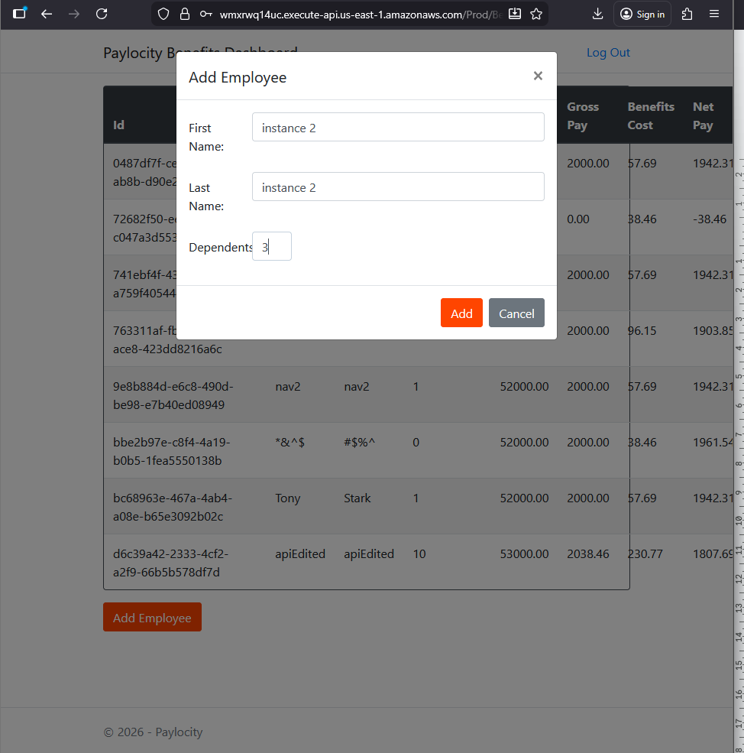

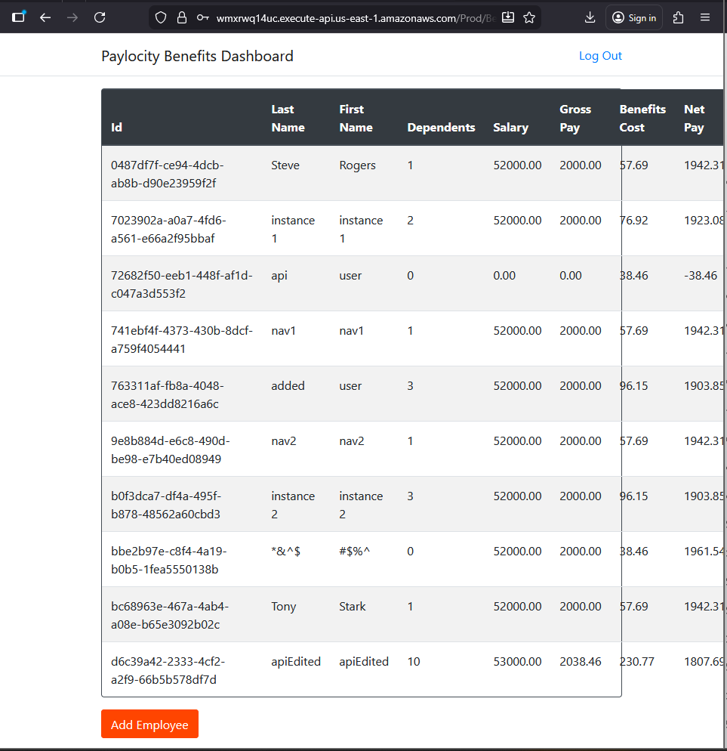

Bug title: Login page crashes when enter invalid username and password
Tester’s Name & ID: Antonio Acosta Flores (antonio.acostafl@gmail.com)
Test Environment: https://wmxrwq14uc.execute-api.us-east-1.amazonaws.com
Priority: 3
Severity: 3

Steps to reproduce the bug:

No. Step | Step Description | Expected Result
1 | Go to the Benefits dashboard Login page | User is landed into the Benefits dashboard login page
2 | Try logging in with both invalid username and password | User should be warned about wrong credentials

Steps with evidence:

No. Step | Step Description | Expected Result
1 | Go to the Benefits dashboard Login page | User is landed into the Benefits dashboard login page

Result:
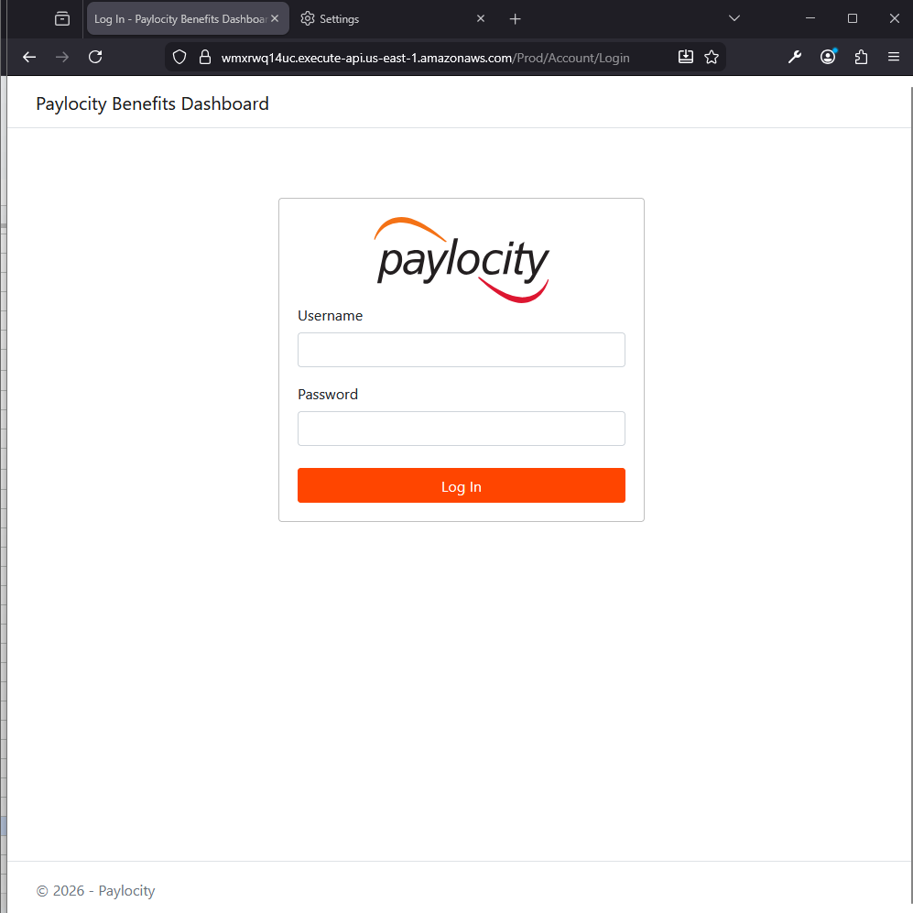

2 | Try logging in with both invalid username and password | User should be warned about wrong credentials  Actual Result:  Page crashes after trying submitting both invalid credentials.

Result:
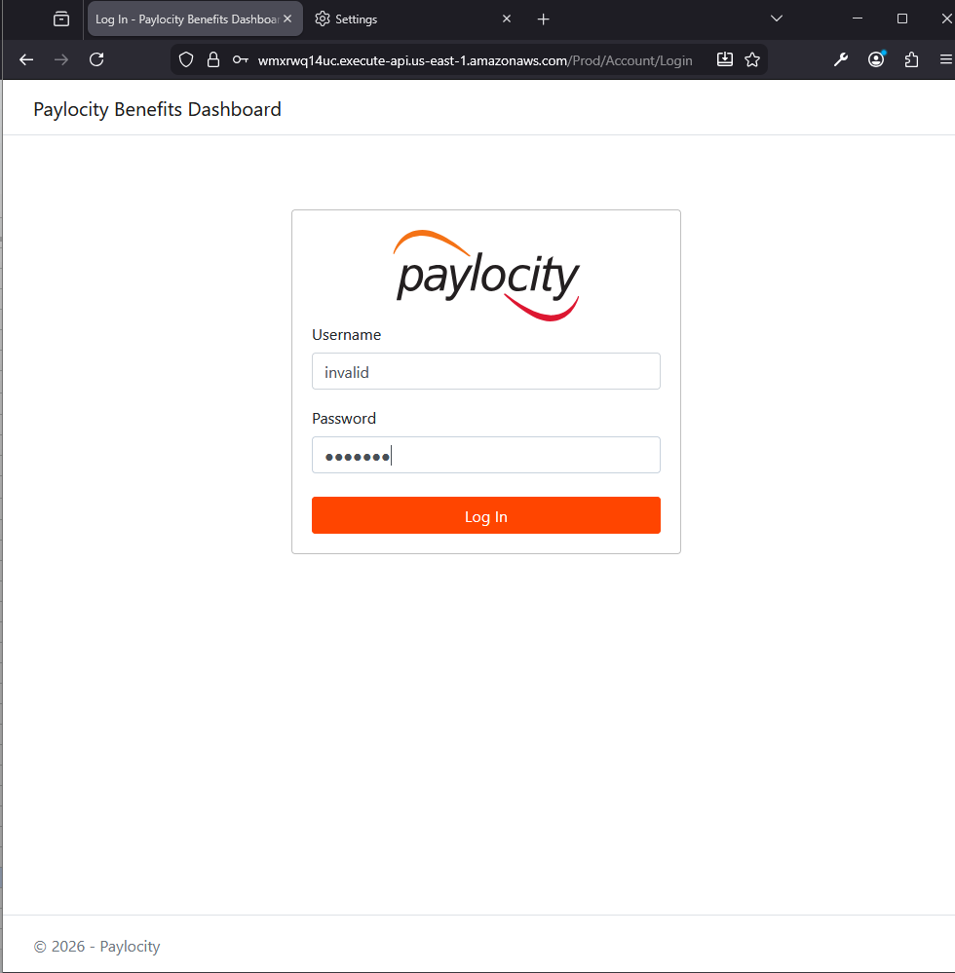

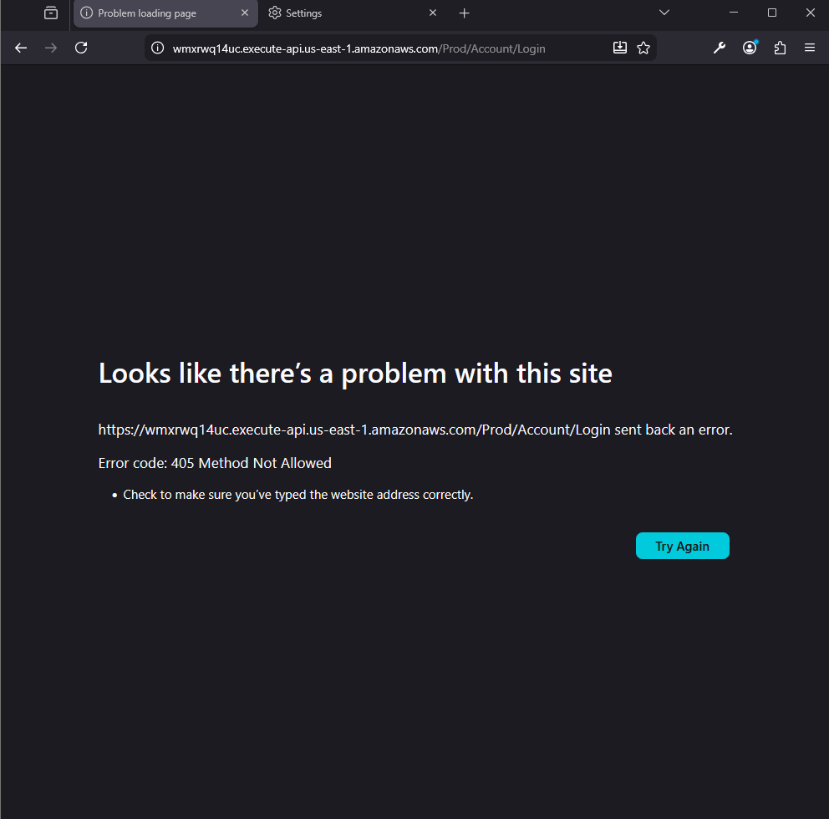

Bug title: Login page crashes when enter invalid username and password
Tester’s Name & ID: Antonio Acosta Flores (antonio.acostafl@gmail.com)
Test Environment: https://wmxrwq14uc.execute-api.us-east-1.amazonaws.com
Priority: 3
Severity: 3

Steps to reproduce the bug:

No. Step | Step Description | Expected Result
1 | Go to the Benefits dashboard Login page | User is landed into the Benefits dashboard login page
2 | Try logging in with invalid username and valid password | User should be warned about wrong credentials

Steps with evidence:

No. Step | Step Description | Expected Result
1 | Go to the Benefits dashboard Login page | User is landed into the Benefits dashboard login page

Result:

2 | Try logging in with invalid username and valid password | User should be warned about wrong credentials  Actual Result:  Page crashes after trying submitting both invalid credentials.

Result:

